**UWashington Department of Fish and Wildlife (WDFW) Recreational Catch Estimation Procedures for Puget Sound Dungeness Crab**

**Summary Document**

DRAFT 10-27-2011

For 2011, separate summer and winter Dungeness crab catch record cards (CRC) were issued only to fishers who purchased a crab endorsement and were required only in Puget Sound marine areas. Fishers purchasing crab endorsements prior to August 26th were only able to receive a summer CRC and were required to pick up a winter CRC at a later date free of charge. Fishers who purchased crab endorsements after could obtain both CRCs if they chose to. Each Dungeness crab CRC was independent from the CRC for all other species. Summer crab CRCs were valid for the period July 1 through September 5 (Labor Day). Winter crab CRCs are valid for the period September 6 through December 31, 2011. Fishers were required to return their summer CRCs to the Department by October 1. As an alternative to mailing the card, fishers were provided the option of reporting their catch on an Internet site developed by the Department. The Internet reporting option was only available after Labor Day (Sept. 5) through October 1. Fishers reporting on the Internet site were required to enter a 14 digit serial number unique to their CRC to verify they were reporting from their card rather than from memory.

Crab fishers were informed that they would be assessed a $10.00 penalty in the form of an administrative fee on their next license purchase if they failed to report their summer catch by the deadline. This was the second summer that a penalty was used to encourage crab fishers to report their catch.

This memo summarizes the July 1, 2011 through September 5, 2011 recreational crab catch produced from the three data sources: returned CRC’s, Internet reports, and non-reported cards corrected for bias.

Catch is reported for Puget Sound Marine Areas 4 through 13. A separate catch estimate was generated for sub-area 25C, which is the portion of MA 9 north of the Hood Canal bridge to a line from Foulweather Bluff to Olele Point, and included in MA 12 (Crab Management Region 5).

Census data from returned CRC’s

A total ? summer Dungeness crab catch cards were issued to 208,462 crab fishers for the 2010 license year. A total of ? fishers returned their CRC by October 1 (Table ?). A total of ? fishers reported their catch information on the Internet (Table ?). Data from all returned summer CRC’s and Internet reports were compiled into a single database and a harvest quantity was generated for each Marine Area from the returned cards (Table ?). These harvest quantities constitute a “census”, or known catch, assuming all catches were recorded on each angler’s CRC and were correctly reported via the Internet. A total of 52% of all crab fishers reported for this census. A weight conversion of 1.8 pounds per crab was used.

**Estimating Recreational Crab Catch 2011 and Beyond**

#### Eliminating the telephone survey and using non-response bias correction factors to estimate catch for non-responders

In previous seasons, the census counts from submitted reports and the estimated non-respondent harvest from the phone surveys were combined to produce an official overall harvest estimate. For the eight reporting intervals since 2007 (4 summer intervals and 4 winter) estimates were also generated for each marine area by expanding the catch from the submitted reports across the entire number of issued cards for that season i.e. a straight expansion. These straight expansion estimates were compared to the official estimates, in order to calculate the non-response bias correction factor for that reporting season. Typically, and as expected, the non-respondents catch fewer crabs per card than respondents, so that a bias correction reduces the estimate from the straight expansion. The average catch per card for the non-respondents was expected to be less than the returned card group because of the higher number of “zero catch cards” that exist in the nonresponders and the anglers perception that zero catch cards do not need to be returned. (There are exceptions, e.g. MA 4, where, based on the phone survey, catch rates are substantially higher for non-respondents. This may prove to be due to an issue with the phone survey design, rather than an accurate reflection of catch rates.)

As expected, bias correction factors differ with return rate. As the percentage of returns increases, the bias correction required decreases. At a 100% return rate, obviously no correction is required. Table 2 shows the calculated correction factors for return rates ranging from 11% to 52%. Figure 2 shows a graphical representation of the bias correction rate including proposed projections for higher return rates up to 100%. This graph shows corrections for the overall estimates, across all marine areas and for the combined returns from mail-ins and the internet.

WDFW in partnership with North West Indian Fishery Commission (NWIFC) biometricians will determine if there are significant differences in non-respondent catch rates between marine areas, and between the two reporting methods. It is also possible that there are differences in the response rate/bias correction curve between summer and winter seasons. Marine area specific bias corrections may be used if the data indicates significant differences in reporting bias exist between marine areas and summer versus winter reporting periods.

These 2011 summer recreational crab estimates are derived by calculating the straight expansion estimates from the submitted reports, and multiplying that estimate by the estimated bias correction factor for that return rate. Catch estimates will be generated using the following calculation:

$N_{r}$ = number of cards reported

$N_{T}$ = total number of cards issued

$H_{r}$ = number of crab reported

$H_{T}$ = estimated total crab harvest

$B$ = non-response bias correction factor

$$H_{T}=h_{r}\left(\frac{N_{T}}{N_{r}}\right)B$$

Summer and winter recreational catch estimates will be summarized to show returned CRCs, Internet reports, and the expanded catch for the non-returned cards based on the bias correction.

Example of Recreational Catch Estimate for Region X

* hypothetical number of CRCs issued 200,000 (*NT*)
* hypothetical CRC return rate of 70% (140,000 returns) (*NR*)
* hypothetical number of crab reported on returned cards and internet 100,000 (*HR*)

1. Bias correction factor (*B*) as a function of the regression analysis equation can be calculated as:

Estimated bias correction Y= -0.50(X)2  + 1.39(X )+ 0.097

Y= -0.50(.70)2  + 1.39(.70) + 0.097

Y= 0.83

1. Estimated catch (*HT*) for Region X

$$H_{T}=h_{r}\left(\frac{N_{T}}{N_{r}}\right)B$$

$$H_{T} =100,000\left(\frac{200,000}{140,000}\right)0.83$$

Region X catch = 100,000 (1.4285)(0,83)

Region X catch = 118,565 crab

____________________________________________________________________________

Table 1

|  |  |  |  |  |  |  |
| --- | --- | --- | --- | --- | --- | --- |
|  | CRCs | CRCs | CRCs | Total | Total | Endorsements |
| Summer | Issued | Returned | Reported Online | Reported | Unreported | Sold, Entire Year |
| 2007 | 210,327 | 34,400 | 32,373 | 66,773 | 143,554 | 226,063 |
| 2008 | 210,893 | 26,037 | 43,919 | 69,956 | 140,937 | 215,643 |
| 2009 | 236,665 | 37,128 | 72,172 | 107,300 | 129,365 | 241,226 |
| 2010 | 208,462 | 29,406 | 77,472 | 107,418 | 101,044 | 213,013 |
| 2011 | ? | ? | ? | ? | ? | Pending |
|  |  |  |  |  |  |  |
| Winter |  |  |  |  |  |  |
| 2007 | 157,905 | 10,281 | 6,388 | 16,669 | 141,236 | 226,063 |
| 2008 | 207,143 | 10,993 | 10,871 | 21,864 | 185,279 | 215,643 |
| 2009 | 89,259 | 11,909 | 27,382 | 39,291 | 49,968 | 241,226 |
| 2010 | 70,763 | 9,633 | 27,346 | 36,979 | 33,784 | 213,013 |
| 2011 | Pending | Pending | Pending | Pending | Pending | Pending |

**Table 2. Response rate and estimated bias correction from telephone surveys for each reporting season.** The correction factor is calculated for catch across all marine areas and reporting types.

|  |  |  |  |
| --- | --- | --- | --- |
| **Year** | **Season** | **Response Rate** | **Estimated Correction Factor** |
| **2007** | Summer | 0.32 | 0.52 |
|  | Winter | 0.11 | 0.25 |
| **2008** | Summer | 0.33 | 0.53 |
|  | Winter | 0.11 | 0.22 |
| **2009** | Summer | 0.45 | 0.63 |
|  | Winter | 0.44 | 0.62 |
| **2010** | Summer | 0.52 | 0.66 |
|  | Winter | 0.52 | 0.67 |

**Figure 1. Comparison of successful trips reported: mail vs. internet.** More no-catch reports are submitted online; more cards with three or more successful trips are sent in by mail.

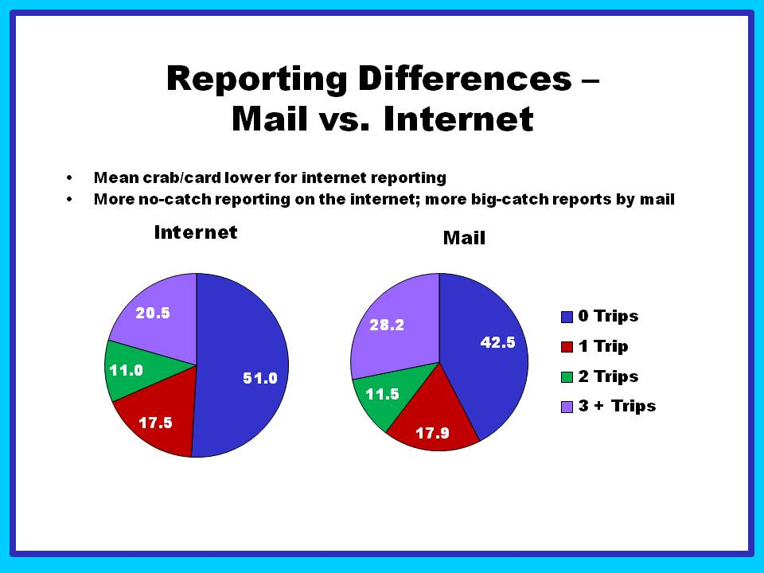**Figure 2. Bias correction by response rate based on data from returned cards and telephone surveys eight reporting periods from 2007 through 2010.**

**Total estimates including non-reported cards.**

|  |  |  |  |  |  |
| --- | --- | --- | --- | --- | --- |
| **Area** | **2011** | | | **Total** | |
| **Jul** | **Aug** | **Sep** | **(#crab)** | **(lb.)** |
| **4** | 378 | 364 | 81 | 823 | 1,482 |
| **5** | 2,697 | 907 | 172 | 3,776 | 6,796 |
| **6** | 45,259 | 15,666 | 4,349 | 65,274 | 117,493 |
| **7** | 106,747 | 129,757 | 34,659 | 271,163 | 488,094 |
| **8-1** | 136,145 | 76,151 | 23,426 | 235,721 | 424,298 |
| **8-2** | 141,665 | 81,586 | 23,714 | 246,964 | 444,536 |
| **9** | 36,716 | 22,000 | 6,911 | 65,627 | 118,129 |
| **10** | 40,302 | 24,229 | 7,233 | 71,764 | 129,175 |
| **11** | 22,482 | 15,344 | 3,499 | 41,326 | 74,387 |
| **12** | 96,967 | 49,038 | 14,660 | 160,665 | 289,197 |
| **13** | 16,047 | 10,636 | 3,247 | 29,930 | 53,874 |
| **Total** | 645,404 | 425,680 | 121,949 | 1,193,034 | 2,147,460 |

**CRC reports mailed in.**

|  |  |  |  |  |  |  |
| --- | --- | --- | --- | --- | --- | --- |
| **Area** | **2011** | | | | **Total** | |
| **Jul** | **Aug** | **Sep** | **Unk** | **(#crab)** | **(lb.)** |
| **4** | 41 | 90 | 15 |  | 146 | 263 |
| **5** | 751 | 326 | 76 |  | 1153 | 2075 |
| **6** | 12875 | 4344 | 1135 | 42 | 18396 | 33113 |
| **7** | 28052 | 34000 | 8184 | 12 | 70248 | 126446 |
| **8** | 1744 | 997 | 286 | 5 | 3032 | 5458 |
| **8-1** | 38588 | 22770 | 6535 | 48 | 67941 | 122294 |
| **8-2** | 39499 | 23255 | 6232 | 34 | 69020 | 124236 |
| **9** | 14950 | 8990 | 2574 | 9 | 26523 | 47741 |
| **10** | 8526 | 5427 | 1427 | 4 | 15384 | 27691 |
| **11** | 5393 | 3712 | 785 | 7 | 9897 | 17815 |
| **12** | 24980 | 11975 | 3217 | 15 | 40187 | 72337 |
| **13** | 3036 | 2233 | 685 | 7 | 5961 | 10730 |
| **Unk** | 2277 | 1856 | 341 | 139 | 4613 | 8303 |
| **Total** | 180712 | 119975 | 31492 | 322 | 332501 | 598502 |

**CRC reports via internet.**

|  |  |  |  |  |  |
| --- | --- | --- | --- | --- | --- |
| **Area** | **2011** | | | **Total** | |
| **Jul** | **Aug** | **Sep** | **(#crab)** | **(lb.)** |
| **4** | 249 | 205 | 49 | 503 | 905 |
| **5** | 1430 | 440 | 74 | 1944 | 3499 |
| **6** | 23769 | 8272 | 2341 | 34382 | 61888 |
| **7** | 58560 | 71019 | 19610 | 149189 | 268540 |
| **8-1** | 75157 | 40934 | 12997 | 129088 | 232358 |
| **8-2** | 82170 | 46950 | 14078 | 143198 | 257756 |
| **9** | 25233 | 15108 | 4926 | 45267 | 81481 |
| **10** | 25949 | 15304 | 4734 | 45987 | 82777 |
| **11** | 13322 | 9069 | 2131 | 24522 | 44140 |
| **12** | 47085 | 23122 | 7054 | 77261 | 139070 |
| **13** | 8230 | 5246 | 1597 | 15073 | 27131 |
| **Total** | 361154 | 235669 | 69591 | 666414 | 1199545 |